Topic : Portfolio

Name : Tanha Tul Tasnim

ID :221-15-5626

Sec : 61_V

#Index.html

Code :

<!DOCTYPE html>

<html lang="en">

<head>

    <meta charset="UTF-8">

    <meta name="viewport" content="width=device-width, initial-scale=1.0">

    <title>My Portfolio</title>

    <link rel="stylesheet" href="styles.css">

    <script defer src="scripts.js"></script>

</head>

<body>

    <header>

        <nav id="navbar">

            <ul>

                <li><a href="#home">Home</a></li>

                <li><a href="#about">About</a></li>

                <li><a href="#education">Education</a></li>

                <li><a href="#skills">Skills</a></li>

                <li><a href="#projects">Projects</a></li>

                <li><a href="#contact">Contact</a></li>

            </ul>

        </nav>

    </header>

    <section id="home">

        <div class="home-container">

            <div class="image-box">

                <img src="photo_2024-05-22_21-21-47.jpg" alt="your name">

            </div>

            <div class="home-text">

                <h1>Welcome to My Portfolio</h1>

                <p>Hello! I am Tanha Tul Tasnim, student of CSE and a future developer .</p>

            </div>

        </div>

    </section>

    <section id="about">

        <h1>About Me</h1>

        <div class="about-container">

            <div class="about-text">

                <p>[Hello! I'm Tasnim, Despite working in the CSE-based industry, I'm also involved in other fields as a content writer, crafter & volunteer. </p>

            </div>

        </div>

    </section>

    <section id="education">

        <h1>Education</h1>

        <div class="education-grid">

            <div class="education-item">

                <h2>Bsc</h2>

                <p>Daffodil International University, Dhaka.</p>

                <p>Waiting to gratuation but already achieved valuable memories with experiences.</p>

            </div>

            <div class="education-item">

                <h2>HSC</h2>

                <p>Comilla City College, passed year 2020</p>

                <p>Got GPA 5 with achievements.</p>

            </div>

            <div class="education-item">

                <h2>SSC</h2>

                <p>Comilla Modern High School, passed year 2018</p>

                <p>Got GPA 5 with achievements.</p>

            </div>

            <!-- Add more education items as needed -->

        </div>

    </section>

    <section id="skills">

        <h1>Skills</h1>

        <div class="skills-container">

            <div class="skill">Volunteering, was volunteer of many events</div>

            <div class="skill">Press security of Cyber Security Club of DIU</div>

            <div class="skill">Content Writter</div>

            <div class="skill">Crafting</div>

            <div class="skill">Energetic person for journey</div>

            <!-- Add more skills as needed -->

        </div>

    </section>

    <section id="projects">

        <h1>Projects</h1>

        <div class="projects-grid">

            <div class="project">

                <h2>Project 1</h2>

                <p>Coffee Shop</p>

            </div>

            <div class="project">

                <h2>Project 2</h2>

                <p>Bank Account</p>

            </div>

            <div class="project">

                <h2>Project 3</h2>

                <p>Calculator</p>

            </div>

            <div class="project">

                <h2>Project 4</h2>

                <p>Quiz Maker</p>

            </div>

            <!-- Add more projects as needed -->

        </div>

    </section>

    <section id="contact">

        <h1>Contact</h1>

        <div class="contact-container">

            <p>Email: <a href="mailto:your-email@example.com">tanha.tul.tasnim@gmail.com</a></p>

            <p>LinkedIn: <a href="https://www.linkedin.com/in/your-profile" target="_blank">Your LinkedIn</a></p>

            <p>Facbook: <a href="https://www.linkedin.com/in/your-profile" target="_blank">https://www.facebook.com/tasnim000001?mibextid=ZbWKwL</a></p>

            <!-- Add more contact details if needed -->

        </div>

    </section>

    <footer id="footer">

        <p>&copy; 2024, Tasnim is right here......</p>

    </footer>

</body>

</html>

#Style.css

Code :

/* Basic reset */

* {

    margin: 0px;

    padding: 10px;

    box-sizing: border-box;

}

/* Body styling */

body {

    font-family: 'Roboto', sans-serif;

    line-height: 2;

    background-color: #f3f3f3; /* Light gray background */

    color: #000000;

}

/* Header styling */

header {

    color: #fff;

    position: fixed;

    align-items: center;

    width: 98%;

    top: 0;

    z-index: 1000;

}

header nav ul {

    text-align: center;

}

header nav ul li {

    display: inline;

}

header nav ul li a {

    color: #fff;

    text-decoration: none;

    font-weight: bold;

    font-size: 18px;

    text-transform: uppercase;

}

@media (max-width: 768px) {

    header nav ul {

        display: flex;

        width: 100%;

    }

    header nav ul li {

        display: flex;

        margin: 10px 10px;

    }

    header nav ul.active {

        display: none;

    }

}

/* Section styling */

section {

    padding: 2rem 2rem;

    text-align: center;

    margin-top: 80px; /* Adjust for fixed header */

}

section#home, #navbar, #footer {

    background: linear-gradient(135deg, #ff7300, #ffb77b); /* Gradient background for home section */

    color: #fff;

    display: flex;

    border-radius: 10px;

    box-shadow: 5px 5px 10px 1px rgba(0, 0, 0, 0.5);

    justify-content: center;

    align-items: center;

}

.home-container {

    display: flex;

    align-items: center;

    gap: 2rem;

    flex-wrap: wrap;

}

.home-text {

    flex: 2;

    font-weight: bold;

    font-size: 24px;

}

.image-box {

    flex: 1;

    max-width: 250px;

}

.image-box img {

    padding: 2px;

    max-width: 100%;

    height: auto;

    border-radius: 50%;

    border: 5px solid #fff;

}

section#about, section#education, section#skills, section#projects, section#contact {

    background: #ffeadd; /* White background for other sections */

    margin: 2rem 0;

    border-radius: 10px;

    box-shadow: 5px 5px 10px 1px rgba(0, 0, 0, 0.5);

    padding: 2rem;

}

.about-container, .contact-container {

    display: flex;

    justify-content: center;

    align-items: center;

    flex-wrap: wrap;

    text-align: center;

}

.about-text {

    flex: 1;

    justify-content: center;

    align-items: center;

    flex-wrap: wrap;

    text-align: center;

}

.education-grid {

    display: grid;

    grid-template-columns: repeat(auto-fit, minmax(300px, 1fr));

    gap: 1rem;

}

.education-item {

    background: #e22161; /* Pink background for education items */

    padding: 1rem;

    border-radius: 10px;

    box-shadow: 5px 5px 10px 1px rgba(0, 0, 0, 0.5);

    color: #fff;

}

section#skills .skills-container {

    display: flex;

    flex-wrap: wrap;

    gap: 1rem;

    justify-content: center;

}

section#skills .skill {

    background: #dfaf20; /* Yellow background for skills */

    color: #333;

    padding: 0.5rem;

    border-radius: 5px;

    box-shadow: 5px 5px 10px 1px rgba(0, 0, 0, 0.5);

    flex: 1 1 calc(33.333% - 1rem); /* Responsive grid items */

    text-align: center;

}

.projects-grid {

    display: grid;

    grid-template-columns: repeat(auto-fit, minmax(300px, 1fr));

    gap: 1rem;

}

.project {

    background: #2982e8; /* Blue background for projects */

    color: #fff;

    padding: 1rem;

    border-radius: 10px;

    box-shadow: 5px 5px 10px 1px rgba(0, 0, 0, 0.5);

}

footer {

    color: #fff;

    text-align: center;

    padding: 1rem 0;

    margin-top: 2rem;

}

footer p {

    margin: 0;

}

/* Responsive adjustments */

@media (max-width: 768px) {

    .home-container {

        flex-direction: column;

        text-align: center;

    }

    .image-box, .home-text {

        max-width: 100%;

        text-align: center;

    }

    .about-container, .contact-container {

        flex-direction: column;

        text-align: center;

    }

    .skills-container {

        flex-direction: column;

    }

    section {

        padding: 2rem 1rem;

    }

}

Script.js

Code :

document.addEventListener("DOMContentLoaded", () => {

    const menuToggle = document.getElementById("mobile-menu");

    const nav = document.querySelector("nav ul");

    menuToggle.addEventListener("click", () => {

        nav.classList.toggle("active");

    });

    // Smooth scrolling for navigation links

    document.querySelectorAll('nav ul li a').forEach(anchor => {

        anchor.addEventListener('click', function (e) {

            e.preventDefault();

            document.querySelector(this.getAttribute('href')).scrollIntoView({

                behavior: 'smooth'

            });

            nav.classList.remove("active");

        });

    });

});

Output : potfolio profile ……..

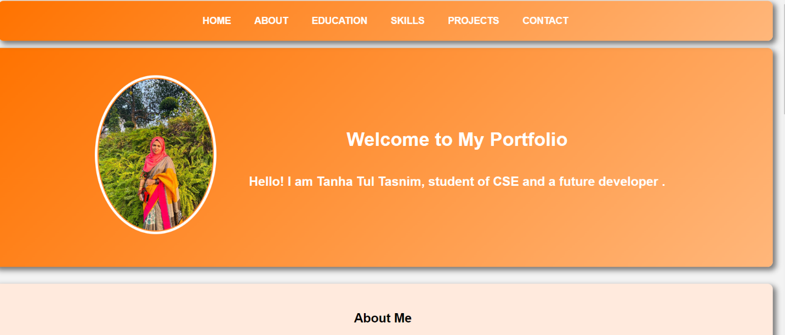

portfolio profile Link : <http://127.0.0.1:5500/index.html#>